

Introduction to SAROPS Interactive Planner
Jan 2009

Thomas M. Kratzke
Sr. Analyst

11911 Freedom Drive  Suite 800  Reston, VA 20190-5602  (703) 787-8700
www.metsci.com
Contents
1. Introduction 1
1.1 Basic Problem for Planner 1
1.2 Planner’s Algorithm 1
1.3 SIP Interaction with the Planner Algorithm 1
2. Solution Colors: Yellow, Dark-Yellow, and Cyan 3
3. Simple Use of SIP 4
4. SIP Screen Components 5
4.1 Double-Clicking Buttons 5
4.2 Left-Hand Side 5
4.2.1 SRUs Panel 6
4.2.2 Object-Types Panel 8
4.2.3 Interaction Panel 8
4.2.4 POS Panel 9
4.2.4.1 Columns of the POS Panel 10
4.3 Right-Hand Side 11
4.3.1 Display Features 11
4.3.1.1 Geo-Displays 11
4.3.2 Re-positioning Buttons 11
4.3.3 Model and Planner Features Buttons 12
4.3.3.1 Legend for Prob/Cond 12
4.3.3.2 Tool-Tip for Prob/Cond in Main-Display 13
4.3.4 Misc. Buttons 13
4.3.4.1 “Animate” (Pause/Stop and Step/Resume) Button 13
4.3.4.2 Sticky Button 13
5. Using Main-Display to Change the Cyan Solution 14
6. Disclaimers 16
6.1 Nature of Document 16
6.2 Starting up and Shutting down 16
6.3 Corner Colors and SRUs 16
6.4 Screen Refreshes 16
6.5 Hovering (Tool-Tip) Bug 16
7. Setting up and Running SimPlanner_CaseViewer 17
7.1 Notes on the Cases 19
7.1.1 ALPHA_MixedEffort 19
7.1.2 ALPHA_UnequalCSTs 20
7.1.3 BRAVO_MixedEffort 20
7.1.4 BRAVO_UnequalCSTs 20
7.1.5 InadequateEffort 20
7.1.6 ThreeHelos 20
7.1.7 TwoModes 22

List of Figures
Figure 1: Ways of Exiting SIP 4
Figure 2: Resulting Dialog 4
Figure 3: Left-Hand Side of SIP Display 6
Figure 4. All SRUs are Displayed in Main-Display. 7
Figure 5. Helo-1 is not Displayed in Main-Display. 7
Figure 6. SRU Tool-Tip 8
Figure 7. Global and All Four SRUs shown for all Object-Types 10
Figure 8. Handles for Manipulating a Cyan Box 14
Figure 9. Control Panel for SimPlanner_CaseViewer 17
Figure 10. Control Panel for SimPlanner_CaseViewer 18
Figure 10. Control Panel for SimPlanner_CaseViewer 19
Figure 11. User Solution after Planner Refined It 21
Figure 12. Best POS Solution 22

Document Revision History

Version Date | Comments
November 5, 2007 | Initial version
January 5, 2009 | Revision 1
March 3, 2010 | Revision 2

Introduction
This document introduces the SAROPS Interactive Planner (SIP), a graphical user interface for SAROPS’ Planner. SIP allows a user to watch Planner develop its solutions, and interact with Planner to produce better solutions. When a user clicks on Run Planner Interactively within SAROPS, he will enter SIP instead of simply seeing a progress bar and waiting for Planner to finish.

Basic Problem for Planner
To understand the concept behind SIP, one needs to know a little about Planner itself. The problem that Planner is trying to solve is the following:
- Find a rectangle for each SRU, in order to maximize the overall POS.
  - The rectangle induces a parallel path search.
  - The pattern will be either PS or CS.
  - The total length of the pattern will be equal to the available path length of the SRU, minus one track spacing.
- Rectangles that correspond to different aircraft must not overlap. Similarly, rectangles that correspond to different surface ships must not overlap.
- Each SRU has a minimum track-spacing, and each SRU’s search leg must be at least as long as its track-spacing.

Planner’s Algorithm
Planner creates a solution by trying many combinations of rectangles for the SRUs. If SIP is not running, Planner quits after 90 seconds (or some predetermined period of time), and reports the best solution that it found. Planner decides on what solutions to try as follows:
- Get an initial solution.
- Refine this solution to eliminate overlap and track-spacing Violations.
- Improve POS, introducing as little overlap as possible and not introducing any track-spacing violation.
- Go to Step 2 if it is reasonable to do so. Otherwise, create another initial solution, and then go to Step 2.
We have omitted the details behind getting an initial solution (a critical step), refining and improving, and getting a different starting point (in Step 4). These details will be discussed in a subsequent report.

SIP Interaction with the Planner Algorithm
When SIP is run, the steps of the Planner Algorithm are shown graphically. For example, in Step 2 above, the user can see what different solutions Planner is trying, while it is eliminating overlap. At any point, the user can see what Planner’s best solution is, and what Planner’s current solution is.
Furthermore, the user can alter these solutions to create his own solution, and ask Planner to apply its algorithm, using the altered solution as a starting point instead of the ones generated in Steps 1 and 4.

Solution Colors: Yellow, Dark-Yellow, and Cyan
As stated above, Planner is always looking for better solutions. At any time, Planner has kept the solution that produced the highest POS, as well as its most recent solution. These solutions are called Planner’s “best” and “current” solutions. Note that Planner might stay with some current solution for quite a while. This happens when Planner cannot easily find a nearby solution that is an improvement.
When SIP is running, Planner’s best solution is drawn in yellow, and its current solution is drawn in dark-yellow. The yellow solution is sometimes called “Best-Pq,” and the dark-yellow solution is sometimes called “Current-Pq.” The user does not need to know how those solutions got those names, but he does need to know that “yellow” is synonymous with “Best-Pq,” and “dark-yellow” is synonymous with “Current-Pq.”
The user will have a solution that is independent of the yellow and dark-yellow solutions. This solution is drawn in cyan (a bright, light blue). We will discuss later how the user can enter and change the cyan solution; right now, we just need to state that there is a solution that is completely under the control of the user. This cyan solution is called “Current-Manual.” Again, the user does not need to know the reason behind this name, but it might be a little easier to guess at than the “Pq” names.
When SIP first comes up, only the yellow solution is visible. There are buttons that will turn the other two to visible (See section 4.2.3), but the default is to show only the yellow solution.

Simple Use of SIP
There is a demo installation that allows you to use SIP on any of several “canned” cases. See Section 7 for installation instructions. We recommend that you run the case “BRAVO_MixedEffort” as you read the rest of this document.
In this section, we go through a very simple use of SIP. Recall that when Planner is run without SIP, there is a time limit, and when that limit is reached, Planner quits. When SIP is run, there is no time limit. SIP simply quits when the user tells it to quit.
So one way of using SIP is to simply watch the yellow solution, and quit when the user thinks that Planner is making no appreciable progress toward a higher POS. When the user is satisfied with the yellow solution, he can simply quit SIP and accept the yellow solution.
To do this, the user can use the “close” box or the “File/Quit and Accept…” menu item. These are pictured in Figure 1. Either way of closing SIP will cause one of the two dialogs shown in Figure 2 (in the demo, only the first will show up). To quit and accept the yellow solution, the user simply clicks the yellow button “Best-PQ.”
Even this limited added functionality can be quite helpful, especially in cases that involve many SRUs.
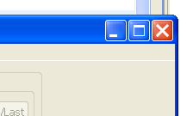 or 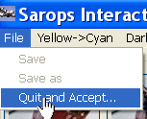
Figure 1: Ways of Exiting SIP
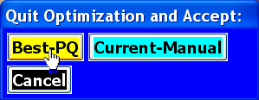 or
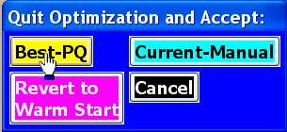
Figure 2: Resulting Dialog

SIP Screen Components
We now describe the screen that is displayed when SIP runs. The SIP screen has a left-hand side and a right-hand side. The left-hand side has an “SRUs panel,” an “Object-Types panel,” an “Interaction panel,” and a “POS panel.” The right-hand side is primarily a display (which is the lower right-hand panel), together with buttons that determine what is displayed. The lower right-hand panel is the main part of the display, and we call it “Main-Display.” Most interaction takes place by moving the cyan solution around in Main-Display. Main-Display is also where SIP draws the particles, probability map, solutions, and patterns.

Double-Clicking Buttons
We need a brief discussion on double-clicking. When a button has a label that has a forward slash (‘/’), the slash indicates that the user can double-click this button. The part of the label that comes before the ‘/’ tells what a single click will do, and the part of the label that follows the ‘/’ describes what a double click will do.

Left-Hand Side
We start our discussion with the Left-Hand side, illustrated in Figure 3. In addition to the menu bar, which we do not discuss in this document, there are four parts to the left-hand side, and we discuss each one below.
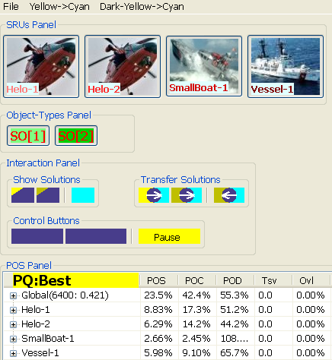
Figure 3: Left-Hand Side of SIP Display

SRUs Panel
The SRUs panel is a row of buttons corresponding to the SRUs. These buttons’ only purpose is to turn on or off the display of that button’s SRU.
In Figure 4, all SRUs are displayed in Main-Display. In Figure 5, we have turned off the display of Helo-1. Note that the button is grayed out, and there is no rectangle in Main-Display, that corresponds to Helo-1.
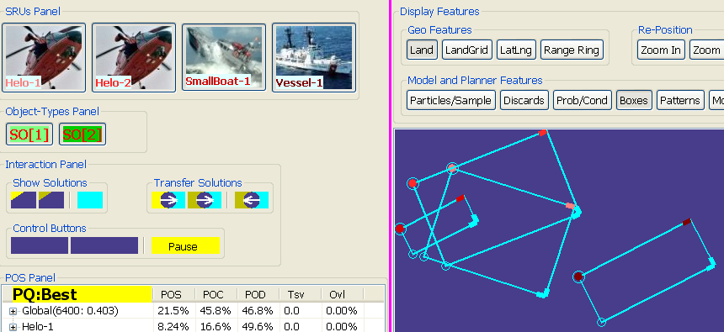
Figure 4. All SRUs are Displayed in Main-Display.
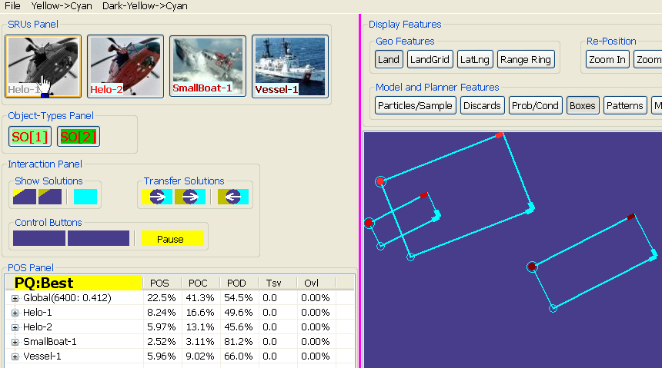
Figure 5. Helo-1 is not Displayed in Main-Display.
“Hovering” over an SRU button causes a small window to pop up and describe the SRU in a very cryptic fashion. This little window is called a tool-tip, and we’ll see other tool-tips when we discuss Main-Display in more detail.
We present an example of an SRU’s tool-tip here. In Figure 6, the tool-tip tells us, among other things, that the sweep-width for Object-Type 1 for Vessel-1, is 4.3 NM.
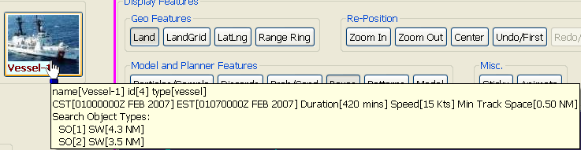
Figure 6. SRU Tool-Tip

Object-Types Panel
The next panel is another list of buttons. These buttons correspond to the object-types within the problem. They too affect only Main-Display.
We will discuss the “Particles” and “Prob/Cond” buttons later, but for right now, we need to say that they are buttons that affect what is shown in Main-Display. When the “Particles” button or the “Prob/Cond” button is clicked, only the particles that are turned on in the Object-Types panel are displayed. Main-Display uses the color of these buttons for the particles.

Interaction Panel
This panel has three clusters of buttons. The first cluster, called the “Show Solutions” cluster, contains buttons that allow the user to select which of the three solutions he wants to see in Main-Display. The second cluster, the “Transfer Solutions” cluster, contains buttons that allow the user to copy the yellow and dark-yellow solution to cyan, and a button that allows the user to copy the cyan solution to dark-yellow. The third cluster, the “Control” cluster, allows the user to undo and redo changes to the cyan solution, and to interrupt Planner’s algorithm.
The buttons in the “Show Solutions” sub-panel are toggle buttons that determine which solutions are drawn in Main-Display. They also allow one to see the POS values for selected solutions in the POS panel. We discuss the POS panel in the next section. When the (e.g.) yellow button is off, the button is almost pure blue; just the upper left-hand corner is yellow. Clicking it turns the display of the yellow solution on in Main-Display, and turns the button to solid yellow. This pattern is followed for each of the two other colors. Since the cyan solution has a different nature than the other two solutions, its “Show” button is slightly separated from the other two.
We now discuss the “Transfer Solutions” cluster. Transferring a solution to cyan is fundamentally different from transferring from cyan. When one transfers to cyan, he is really using a shortcut for entering a new cyan solution. When one transfers from cyan, he is telling Planner to use the cyan solution for a starting point in Planner’s algorithm (note that the only “from” operation is to dark-yellow.). This difference in nature is also emphasized in the layout of the cluster’s buttons. The “cyan-to-dark-yellow” arrow goes right to left, and is slightly separated from the other two buttons.
The “Control Buttons” allow the user to “undo” and “redo” changes he made to the cyan solution, and to interrupt Planner’s algorithm. Double-clicking the “Back/Home” button will send cyan back to its first solution, and double-clicking the “Forward/Last” button will send cyan to its last solution. Both of these buttons are inactive and solid blue if they are inapplicable. In particular, when the program first starts, there is only one cyan solution, and no previous or next one to go to. Hence, the program starts with both of these buttons solid blue and inactive.
The last button in this cluster allows the user to pause Planner’s algorithm. Clicking this (yellow) button turns it to “Step/Resume.” Double-clicking the “Step-Resume” button starts Planner’s algorithm again, whereas single-clicking it just allows the dark-yellow solution to move one time. Since such a movement can be quite small, and only one SRU will move, it might be quite difficult to notice. Furthermore, as stated before, there can be quite a delay between movements of the dark-yellow solution. For these reasons, we recommend that the user not try to “step” Planner’s algorithm. If the user “pauses” it, it’s simplest to just double-click it and resume.

POS Panel
The bottom panel on the left-hand side is the POS panel. It displays POS values for one of the three solutions, but just one solution at a time. The top line’s color indicates which solution is being used to fill out the table. By clicking on the top line, the user can change which solution he wishes to see the POS values for. Only those solutions that are “shown” as per the “Show Solutions” cluster, can be viewed in the POS panel.
The “Global” line is for all of the search effort put together, and the lines corresponding to the individual SRUs appear underneath the “Global” line. Furthermore, each of these lines can be “opened up” to see how “Global” or an individual SRU fared against a particular Object-Type. We have opened up all 4 SRUs in Figure 7, and shown the yellow solution in Main-Display as well.
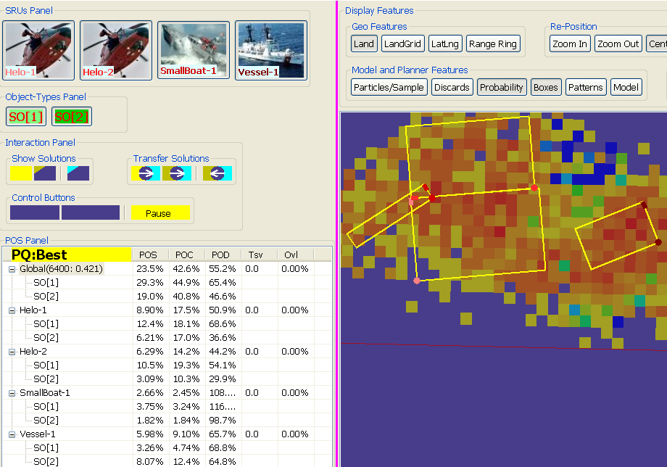
Figure 7. Global and All Four SRUs shown for all Object-Types
The “Global” label has some numbers trailing after it. These are technical in nature and the user can ignore them. For the curious, we discuss them here.
Planner rarely computes the complete POS for a given solution. Rather, Planner evaluates POS for a large enough sample of particles to be convinced that the average of the POS values for the particles in the sample is close to the true POS. The first number that follows “Global” is the number of points that Planner used in this process for that solution. The second is the “experimental standard deviation” of the sample POS values. The smaller that number is, the more likely it is that Planner’s estimate will be close to the true POS value. Only by closing Planner, accepting this solution, and going back to SAROPS, will we really know what the true POS value is for this solution.

Columns of the POS Panel
The most important column is the first one, POS. The most important row is the first one (Global). In fact, the POS value of the Global row is the number we are trying to maximize.
POC and POD are legacy columns; prior to SAROPS’ Planner, the computation of POS was the product of these two numbers. Planner does not use POD and POC, and does not even compute them. Rather, it starts with POS, and computes numbers that are similar in spirit to the old POC and POD. SIP does this for comparison with the older method.
The final two columns tell how badly the constraints have been violated. The Tsv column shows how badly the “Track-Spacing” constraint has been violated; zero means no violation at all. The Ovl column shows how badly the “Overlap” constraint has been violated; again zero means no violation at all. With many SRUs, Planner can take well over 90 seconds just to drive these violations to zero. In these cases, SIP is useful just to wait until these violations vanish.

Right-Hand Side
There are only two panels on the Right-Hand side. The top panel is called “Display Features” and is a collection of clusters of buttons that control what the bottom panel displays. The bottom panel is Main-Display.

Display Features
The four clusters of buttons in the Display Features panel are: “Geo-Displays,” “Re-positioning,” “Model and Planner Features,” and “Misc.”

Geo-Displays
The buttons in this cluster control geographical features. The user can turn the display of land on and off by toggling the “Land” button. Toggling the “Lat/Lng” button causes the Lat/Lng of the cursor to be displayed next to the cursor.
Clicking on the “Range Ring” button allows the user to move the cursor to Main-Display, click on it, and drag. A ring appears with the distance in nautical miles to the center of the circle. This button can utilize the “Sticky” button in the “Misc.” cluster. When “Sticky” is “on,” one can run Range Ring multiple times without going back and clicking the “Range Ring” button for each one. Otherwise, when the user is finished with a particular Range Ring, he would need to click the “Range Ring” button again to compute another Range Ring.

Re-positioning Buttons
The buttons in this cluster control the portion of the earth that is shown by Main-Display. When one clicks on the “Zoom+” button, he then moves the cursor to Main-Display and “rubber-bands” a rectangle. The smaller the rubber band when the user lets go of the mouse, the more zooming will occur. Main-Display will end up centered on the center of the rubber-band’s rectangle.
Clicking on the “Zoom-” button causes the opposite to happen. Again, a rubber-band will be used, and Main-Display will end up centered on the center of the rubber band. This time, the smaller the rubber-band, the farther out the user zooms.
The “Drag” button causes a re-centering, but no change in scale. When the user clicks on the “Drag” button and then drags some point on Main-Display, the view of the world will be shifted, so that the point on the earth where the pressed the mouse button, is now drawn where the user released the mouse button. This shifting is only approximate.
The “Undo” and “Redo” buttons undo and re-do the last “Zoom+,” “Zoom-,” or “Center” operation. Undo and Redo can be clicked multiple times. But be patient, and wait to see the effect of each one, before clicking it again. Note that the “Undo” and “Redo” buttons can be double-clicked to get back to the first view, or to the most recent view.
The “Zoom+,” “Zoom-,” and “Drag” buttons can take advantage of the “Sticky” button, discussed below. When “sticky” is “on,” one can make consecutive zooms without going back and pressing the zoom buttons between each zoom. Similarly, the user can shift the display without pressing the “Drag” button between each drag.
These Re-positioning operations can be time-consuming. Be patient. For example, after clicking the “Drag” button, wait for the screen to re-center before hitting it again.

Model and Planner Features Buttons
The buttons in this cluster allow the user to choose what he wants to see in Main-Display. In that sense, they are very similar to the “Land” button in the Geo Features cluster. One can turn on or off the display of the solutions’ boxes, the patterns within the boxes, the particles, and the probability grid. He can also see most of the elements of the model that went into the simulation, by turning on the “Model” button. The model includes features such as previous searches, hazards, the routes of voyages, etc.
We will discuss the “Particles” and “Prob/Cond” buttons since they can be the most confusing. Recall the Object-Types panel in the Left-Hand side. In that panel, there is a button for each Object-Type. The program starts with all of these buttons “on.” The user can turn some of them off. We call an Object-Type “on” or “off” according to the Object-Types panel.
When one views the particles by clicking the “Particles” button, only the particles that have an Object-Type that is “on,” are displayed. Similarly, when one views the probability map by single-clicking the “Prob/Cond” button, the probability grid is based only on the same set of particles. If one double-clicks the “Prob/Cond” button, he will see the probability grid that is based on the probabilities of the same set of particles, but conditioned on the particle being one of these “on” Object-Types.

Legend for Prob/Cond
The legend that appears to the right has all of the colors that the probability and conditional grids use. Alternate colors have a pair of numbers to the left of it. We explain these numbers here.
The second number is straightforward; it is the upper bound of that color’s value. So if there are 6400 cells, an average value (yellow) would have an upper bound of 1/6400. This is not intuitively very meaningful since, to most people, 1/6400 does not obviously indicate “average.”
The first number is a scaled version of the second number that results in a more intuitive scale. In this scale, “average” is 1.0.
Note that both scales are logarithmic. In other words, the ratio of two consecutive upper bounds is constant. Finally, the highest upper bound is the highest number that we might like to display. When we animate (see “Animate Button”), this scale will change dynamically since both the number of cells change, and the highest number we’d like to see also changes.

Tool-Tip for Prob/Cond in Main-Display
When the user hovers the mouse over one of the cells of the probability grid, a tool-tip pops up and displays the ratio of that cell’s weight to the average weight of a cell. In other words, the tool-tip displays a number that is comparable to the first number of the legend.

Misc. Buttons

“Animate” (Pause/Stop and Step/Resume) Button
The “Animate” button will step the display through a sequence of time periods. This will not affect the boxes of the solutions, but it will affect the patterns, the particles, the probability (or conditional) grid, and possibly the model.
One use of the “Animate” button is to see where each pattern is, relative to the particles’ positions. Planner’s algorithm does not assume a static collection of points. It computes POS based on the movement of both the particles and the SRUs. The “Animate” button allows the user to see the positions of solutions’ SRUs relative to the positions of the particles.
Clicking “Animate” turns the button to the double-clickable button “Pause/Stop.” Double-clicking this will bring it back to the original state. Single-clicking will cause the animation to pause, and turn the button to “Step/Resume.” Single-clicking the “Step/Resume” button will cause it to go to the next “frame,” and double-clicking it will cause it to continue its animation.

Sticky Button
We discussed this button in the section on the “Range Ring” button, and the “Re-positioning” buttons. When the “Sticky” button is on, the user does not have to re-click these buttons repeatedly to repeat their effect; he can keep on Main-Display. This affects the “Range Ring” button, and the three main Re-positioning buttons.
Because the “Sticky” button interferes with the interactive nature of SIP, we recommend that the user usually keeps the “Sticky” button “off.”

Using Main-Display to Change the Cyan Solution
In the simple use of SIP, there was practically no user input. The user just watched the yellow solution change. Indeed, the user cannot (directly) edit the yellow solution. The user can use Main-Display to edit the cyan solution, and this is the typical way that cyan solutions are modified.
The user never creates a cyan solution from scratch. A cyan solution exists at the beginning of the program, and he can also copy over solutions from either the yellow or the dark-yellow solutions. He can also edit a cyan solution by altering any one of the boxes, and that process is what this section is about. As soon as a box is altered, the user has actually created a new solution.
To start, the user must click the cyan “Show Solutions” button, so the cyan solution will be visible in Main-Display. After doing so, there are three ways that the user can alter one of the cyan solution’s boxes. They correspond to the handles on the boxes’ three corners. Note that there is only one corner of a cyan box that has no cyan “ornamentation.” The other three corners are listed below, and illustrated in Figure 8.
- Big Filled-in Circle: Dragging this circle moves the entire rectangle.
  - Hovering over this, for the cyan solution, gives identifying information about the SRU.
- Small Empty Circle: Dragging this circle twists the rectangle about its center.
- “Corner” Handle: Dragging this corner stretches or shrinks the rectangle.

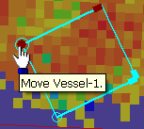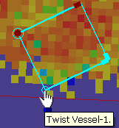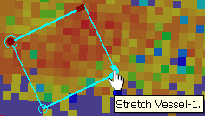
Figure 8. Handles for Manipulating a Cyan Box
The “Corner” Handle is the most confusing. The constraints of the problem limit the different sizes of rectangle that we can use. As one drags the “Corner” Handle, the rectangle “lurches” to the next acceptable rectangle. This effect is most noticeable when there are few legs.
This manipulation of the boxes is why we recommend that the “Sticky” button be kept off; it can interfere here.
Note that in Figure 8, there is a tool-tip for these movements.

Disclaimers

Nature of Document
This document is an introductory “Getting Started” guide for SIP. It is not a technical document describing the mathematics behind the Planner Algorithm, nor does it describe all of the features of SIP.

Starting up and Shutting down
SIP can take some time to load and to finish. Furthermore, SIP does nothing more than change the cursor to a “busy indicator” during these pauses.
Planner constructs an initial solution before the SIP screen comes up, and that can take some time. Moreover, when the user accepts a solution, SIP has to go through the entire eval algorithm. This can cause a noticeable delay until SIP completely closes down and SAROPS returns. The user is encouraged to click carefully and practice patience.

Corner Colors and SRUs
To manipulate an SRU, the user needs to know which SRU the box corresponds to. We discussed this briefly when we introduced the SRU panel. Each SRU in the SRU Panel has its name written in a particular color. That color shows up in a corner of the box that corresponds to the SRU in Main-Display.
Because the reds of the SRUs can be hard to tell apart, the user might want to identify an SRU’s box by clicking it off and on in the SRU panel, and watching which box turns off.

Screen Refreshes
Changing screen resolutions and positions can cause an awkward delay. Be patient and wait for the screen to come back before trying another operation.

Hovering (Tool-Tip) Bug
Hovering to get a tool-tip works, but frequently, you have to hover, move away, and then come back and hover again.

Setting up and Running SimPlanner_CaseViewer
There is a demo program for the interactive planner, called SimPlanner_CaseViewer, and it has an installation .exe file. Double-click the .exe file and follow all of the defaults.
Then, under the Start button, click All Programs and look for the program group SimPlanner_CaseViewer. Inside of that, there is a button also called SimPlanner_CaseViewer. Clicking that will start the program, and you will see:
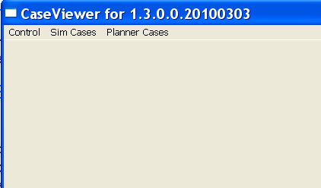
Figure 9. Control Panel for SimPlanner_CaseViewer
Click on the Sim Cases menu item and you will see a long list of cases that can be run (Figure 10). Consider just those that start with “Planner.” Click on one of those. Nothing will happen for a while as the simulator is running to create a particle file for planner to work with.
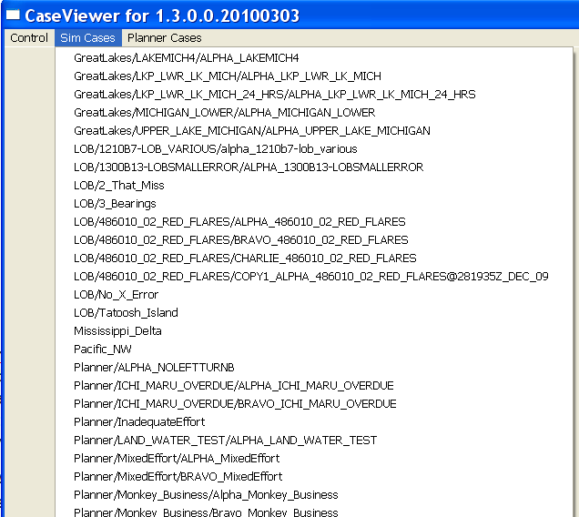
Figure 10. Control Panel for SimPlanner_CaseViewer
Once the simulator finishes, you can go over to the planner menu item and click on any of the “enabled items” (Figure 11).
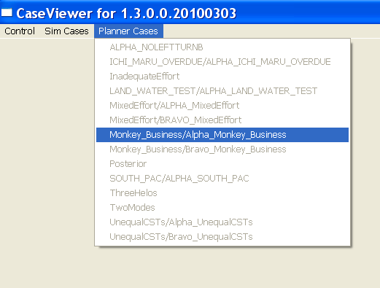
Figure 11. Control Panel for SimPlanner_CaseViewer
Even though this is a demo program that comes with a set of cases, Planner is running “live.”
As noted in §6, some of the demo cases will take a long time to exit. In particular, the case Alpha_UnequalCSTs can take up to a minute. No crash has been experienced with this case, but it has tried some people’s patience!

Notes on the Cases
We consider the cases alphabetically.

ALPHA_MixedEffort
Planner does a good job here. There are two modes and it finds them and places the SRUs over them. Try clicking the “Prob/Cond” button and animating. This is a good problem to practice on. 53% is a good estimated POS for this one.

ALPHA_UnequalCSTs
This is a very difficult problem. The helos arrive significantly after the other two SRUs. A challenge to the user would be to get the estimated POS up to 82%. Note that the object type “-1” is invisible to all SRUs and you should probably click it “off” and double-click the “prob/cond” button for a more accurate picture of what you’re optimizing. There is significant mass drifting to the west that is all object-type “-1” and you want to avoid being misled by that.
This one is tricky enough for the user to really contribute ideas. I’ve let this one run overnight before, and it still found better answers after hours of working.

BRAVO_MixedEffort
24% would be a good answer on this one. Make sure that “Prob/Cond” is on, and look at where Planner puts the rectangles; mostly over red squares, and “SmallBoat-1” overlaps the two helos. Turn the patterns on. Can you do better? A good starting point would be to click the button in the “Transfer Solutions” cluster that transfers yellow to cyan, and play with the cyan solution for a while. Then turn the dark-yellow solution on, and the yellow one off. Use the “separated” button in the same cluster to transfer the cyan solution to the dark-yellow solution, and see if Planner can top its previous yellow solution.

BRAVO_UnequalCSTs
This is an interesting problem, and illustrates how our heuristic could use a nudge. The rectangles initially come up, and the user would really like to twist the western one around to the north. Planner is reluctant to do that because it would cross through the eastern one before it got “into the clear.” Once you twist the left rectangle, Planner admits its error, and runs with the better solution. 35% is a good estimated POS for this one.

InadequateEffort
This problem is lacking on resources. Note the miniscule sweep-widths. 3% is a good answer here.

ThreeHelos
This is a difficult problem. Planner stubbornly refuses to go after the mass in the northwest. If you move a rectangle up there and adjust the other two a bit, and then ask Planner to run with that suggestion, you might get a better answer. Anything above 22% in this case is outstanding.
This is one case where the user might not prefer the yellow solution. Moving an SRU to the northwest gives a more intuitive plan, but a POS that is (barely) smaller. The two solutions are illustrated in Figure 12 and Figure 13.
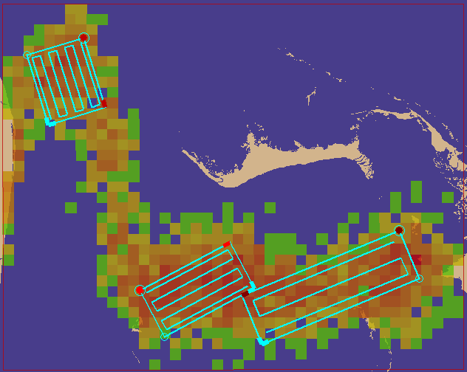
Figure 12. User Solution after Planner Refined It
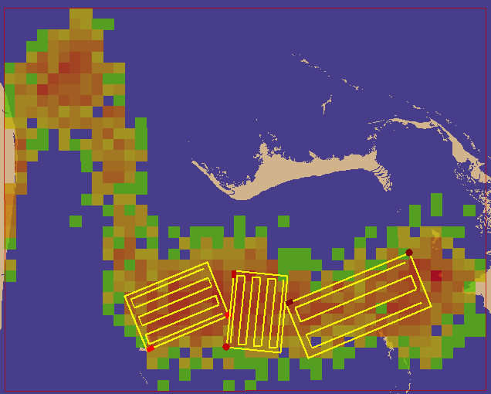
Figure 13. Best POS Solution

TwoModes
Planner split the two SRUs fairly quickly on this one; it zeroes in on a good answer, and the user might want to stop it before the 90 seconds would elapse. This is the old “Ichi Maru Overdue” case. Planner has gone through several re-writes since the time when it put the two SRUs together and only split them later on.

